ASTRONOMY 100

Unit 5 Homework

1. List and describe/define the major functions of a telescope?

2. What two different components of a telescope can be used to focus light?

____________________________ & _______________________________

3. What major problem did the Hubble telescope originally have, and how was it corrected?

4. Briefly describe the three types of telescopes (shape? Lens? Mirror? Both? Cost? Use?)

5. What is the difference between good ‘seeing’ and good ‘transparency’? Give one condition for each.
6. Which of the seven types of EM spectra can survive the trip through our atmosphere and reach the ground (even if it is just partially)?
7. Which telescope can produce brighter images (gather more light)? A. 5” B. 6” C. 8”
8. If two stars are separated by only 0.85” (seconds of arc) in the sky, which of the following telescopes would only see one star (review the telescopes ppt)? One with a resolving power of: a. 0.50” b. 0.90” c. 0.85”
Short Answer / Essay Questions:
[The answer must include all relevant information, yet not include a lot of non-relevant information for full credit. Even though you will be referencing various resources, you need to compose your answer primarily in your own words. A completely (or heavily) copied response will also result in a deduction of points. A good rule of thumb would be to attempt to explain the question to a peer who has not taken your astronomy class.]

Answer in AT LEAST 5-7 complete sentences for full credit.

9. Why do we bother making space-based telescopes? Make sure to answer the main reason WHY. Include limitations of Earth-based telescopes and the advantages of space-based telescopes in your answer for full credit.

10. Why is magnification NOT the most important consideration in purchasing a telescope? Make sure to include appropriate definitions and other considerations that are most important for full credit.

Define the following terms:
- light gathering power -
- resolving power -
- magnification -
- exit pupil -
- refractor -
- reflector -
- Schmidt-Cassegrain -
- Transparency -
- Seeing -

ASTRONOMY 100

Unit 6 Homework

1. How many planets are there in the solar system (don’t count dwarf planets)?
a. 8 b. 9 c. 12 d. 13

2. What is the most abundant (non-observable) material in our galaxy?

3. What are the two most abundant elements of the universe? (choose all that apply)
a. hydrogen b. helium c. carbon d. iron e. oxygen

4. What object (or objects) is (are) the second most massive component of the Solar System?

5. What are Dwarf Planets also known as?

6. Type in at least four differences between the planets (I did one for you. You do four more. Use the text and my presentations to help you answer this question).

Inner Planets (Terrestrial) | Outer Planets (Jovian)
Close to each other  a.  b.  c.  d. | Far From each other  a.  b.  c.  d.

7. What were planets typically named after?

8. Where are the asteroids found? What is the shape of their orbits?

9. Where are the comets found? What is the shape of their orbits?

10. Which of the two objects (asteroids or comets) is mostly made of rock?

11. Which (asteroids or comets) is mostly made of ice?

12. What is the main thing that differentiates meteors and meteorites?
a. size b. location c. shape

13. What are meteor showers named after?

14. What were the main stages of the solar system formation theory? (List with a brief explanation of each)

15. What are the main methods of detecting exoplanets? (List them and briefly describe them)

Define the following terms:

- Solar system -
- Asteroid -
- Comet -
- Ion tail -
- Dust tail -
- Exoplanet -
- Meteor -
- Meteorite -
- Meteoroid -

Use the planetary data grid to answer the following 7 questions:
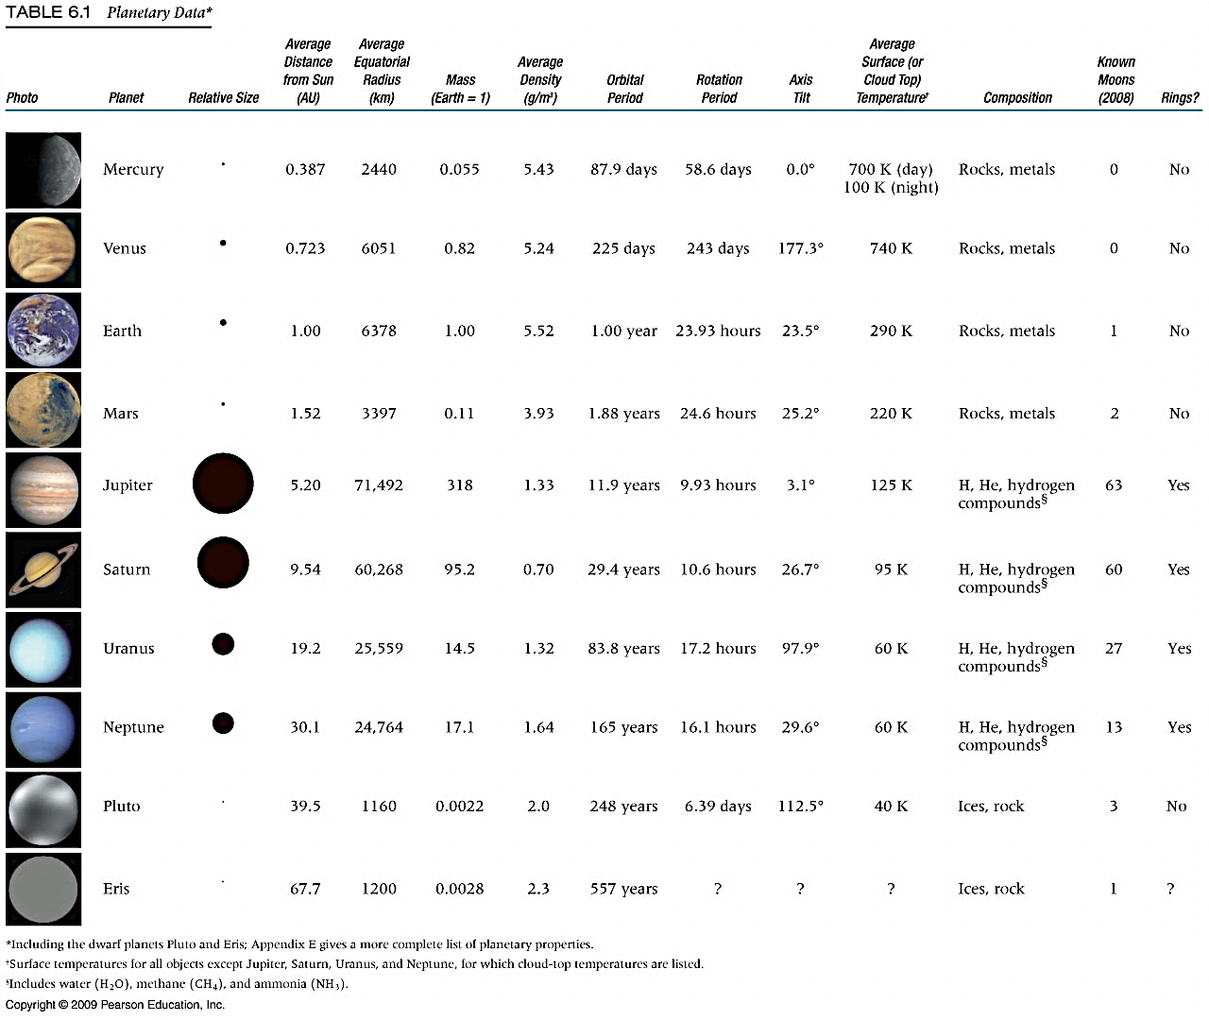

16. List the 5 terrestrial worlds (include the moon) in order from smallest to largest.

17. Which of the inner planets gets the HOTTEST?
a. Mercury b. Venus c. Earth d. Mars

18. Which planet is most like the Earth in size?
a. Mercury b. Venus

19. Which planet has nearly the same length Day as Earth?
a. Mercury b. Venus c. Mars d. Jupiter

20. Which planet will celebrate only ONE year in the same amount of time the average human lives their ENTIRE life? a. Mercury b. Venus c. Mars d. Jupiter e. Saturn f. Uranus g. Neptune

21. What pattern do you notice about average distance from the Sun, and length of year?
A. longer year B. shorter year C. no pattern

22. What pattern do you notice about size of planet and length of day?
A. longer day B. shorter day C. no pattern
Short Answer / Essay Questions:

[The answer must include all relevant information, yet not include a lot of non-relevant information for full credit. Even though you will be referencing various resources, you need to compose your answer primarily in your own words. A completely (or heavily) copied response will also result in a deduction of points. A good rule of thumb would be to attempt to explain the question to a peer who has not taken your astronomy class.]

Answer in AT LEAST 5-7 complete sentences for full credit.

23. Contrast the formation of the atmospheres between the inner and outer planets. Make sure to include identifying features of each for full credit.

24. What is a NEO, and why should we be concerned about them? Fully define a NEO, processes, and consequences for full credit.

25. What are the differences between the two tails of a comet? Describe the differences and why there are differences.

ASTRONOMY 100

Unit 7 Homework

1. What are the two main heat (energy) transport regions of the sun?

_______________________________ and ________________________________

2. In which of these regions does energy take millions of years to traverse? ____________________

3. What are the two main regions of the Sun’s atmosphere?

_______________________________ and ________________________________
4. What are the two possible outcomes if the Sun does not maintain hydrostatic equilibrium?
5. List the layers of the Sun inward, in order, from Corona to Core.
6. What are three features of the Sun that the Sun’s strong magnetic field is responsible for?

Short Answer / Essay Questions:

[The answer must include all relevant information, yet not include a lot of non-relevant information for full credit. Even though you will be referencing various resources, you need to compose your answer primarily in your own words. A completely (or heavily) copied response will also result in a deduction of points. A good rule of thumb would be to attempt to explain the question to a peer who has not taken your astronomy class.]

Answer in AT LEAST 5-7 complete sentences for full credit.

7. Explain the phrase (in at least 3 sentences) “The Sun generates energy at the expense of consuming itself.” Describe how the Sun generates energy, and clearly explain the phrase for full credit. You will likely do better if you try to explain in your own words.

8. Why are sunspots cooler than their surrounding regions? Make sure to define sunspots, the process of sunspot formation, and the process required for the temperature difference for full credit.

Define the following terms:

- hydrostatic equilibrium –
- granule –
- granulation –
- photosphere –
- chromosphere –
- radiative (radiation) zone –
- core –
- corona –
- chromosphere –
- convection zone –
- prominence –
- solar flare –

ASTRONOMY 100

Unit 8 Homework

1. What properties of stars does the spectral type describe?

2. What properties of stars are plotted on the H-R diagram?

3. Which stars age faster? High mass or low mass?

4. Which luminosity class represents stars that are still fusing hydrogen into helium?

5. Which star is brighter? Mag +3 or Mag +10?

6. What are the spectral types in order (from coolest to hottest)?

7. What are the three main luminosity classes?

8. What are the four main groups on the HR diagram? What is a property of each?

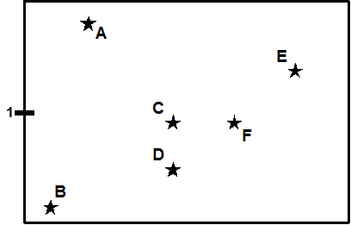
Use the following H-R Diagram to answer the following questions (you may want to review how to read an H-R diagram first)

9. Which is the hottest? A) Star B B) Star E C) Star D

10. Which star is larger (C or D)?

A) C B) D C) Neither. They are the same size

11. Star C is _______ star D. A) hotter than B) the same temperature as C) cooler than

12. Stars C and F share the same A) temp. B) size C) nothing

13. Which pair of stars have the same luminosity (brightness)? A) C & F B) C & D C) A & C

Draw and label each of the stars below (in questions 14-16) on the HR diagram above (or copy a picture to your homework).

You will have to label the vertical and horizontal axis as in your book or presentations. Answer the following questions using your drawings:

14. Which is brighter? A) B2V or B) G2V

15. Which is brighter? A) K5V or B) G2III

16. Which is larger? A) B6V or B) M3I
Short Answer / Essay Questions:

[The answer must include all relevant information, yet not include a lot of non-relevant information for full credit. Even though you will be referencing various resources, you need to compose your answer primarily in your own words. A completely (or heavily) copied response will also result in a deduction of points. A good rule of thumb would be to attempt to explain the question to a peer who has not taken your astronomy class.]

Answer in AT LEAST 5-7 complete sentences for full credit.

17. What is the difference between luminosity and apparent brightness? Give a real-world example to explain it to someone who is not in the class.

Define the following terms:

- apparent brightness –
- luminosity –
- H-R diagram –
- Main sequence –
- Supergiants –
- Giants –
- White dwarfs –
- Black hole –
- Neutron star –
- Spectral type
- Luminosity class

ASTRONOMY 100

Unit 9 Homework

Fill in the blanks (please type or write your answer in a different color or in Bold):

Stellar evolution

_______________ holds stars together; _________________ supports stars against gravity.

_______________ and ___________ forces must balance.

______________ is created by __________ _______________ in a star’s core.

_____________ _____________ cause ______________ to flow from the core to the surface,

where it escapes into space as the star’s ____________________ (starlight).

Escaping ___________ is replenished by __________ _____________ in the core. (Hydrogen

Fuses to helium initially). The star eventually runs out of __________.

Lo-mass stars (M < 10 solar masses) turn into ________________ ___________________. High

Mass stars (M > 10 solar masses) explode, leaving a _____________ ______________ or

_____________ ______________.

Word Bank (you may use a word more than once)

fuel, black, heat, high, pressure, white, temperature, hole, gravity, fusion, luminosity, neutron, dwarf, nuclear, star

Short Answer / Essay Questions:

[The answer must include all relevant information, yet not include a lot of non-relevant information for full credit. Even though you will be referencing various resources, you need to compose your answer primarily in your own words. A completely (or heavily) copied response will also result in a deduction of points. A good rule of thumb would be to attempt to explain the question to a peer who has not taken your astronomy class.]

Answer in AT LEAST 5-7 complete sentences for full credit.

- Why do high mass stars age faster than low mass stars? Make sure to answer why with definitions and processes for full credit.

- Imagine plotting all the stars of a particular globular clusters on an HR diagram. Note that all stars in a particular cluster form around the same time. Describe a few ways that we can determine the relative ages of each cluster using an HR diagram. [Hint: use your ppt presentations to help you answer this question. Think of the turnoff point in section 22.3.]

Define the following terms:

- Main sequence –
- Supergiants –
- Giants –
- White dwarfs –
- Black hole –
- Neutron star –
- Nebula Theory (Solar Nebula Hypothesis)

